**Problem Statement:**

You work for XYZ Corporation. Your corporation wants to launch a new web-based application. The development team has prepared the code but it is not tested yet. The development team needs the system admins to build a web server to test the code but the system admins are not available.

**Tasks To Be Performed:**

1. Web tier: Launch an instance in a public subnet and that instance should allow HTTP and SSH from the internet.

2. Application tier: Launch an instance in a private subnet of the web tier and it should allow only SSH from the public subnet of Web Tier-3.

3. DB tier: Launch an RDS MYSQL instance in a private subnet and it should allow connection on port 3306 only from the private subnet of Application Tier-4.

4. Setup a Route 53 hosted zone and direct traffic to the EC2 instance.

**You have been also asked to propose a solution so that:**

1. Development team can test their code without having to involve the system admins and can invest their time in testing the code rather than provisioning, configuring and updating the resources needed to test the code.

2. Make sure when the development team deletes the stack, RDS DB instances should not be deleted

**Launch a multi-tier-stack**

* Web tier: Launch an instance in a public subnet and that instance should allow HTTP and SSH from the internet.

* Application tier: Launch an instance in a private subnet of the web tier and it should allow only SSH from the public subnet of Web Tier-3.

* DB tier: Launch an RDS MYSQL instance in a private subnet and it should allow connection on port 3306 only from the private subnet of Application Tier-4A screenshot of a computer

  Description automatically generated

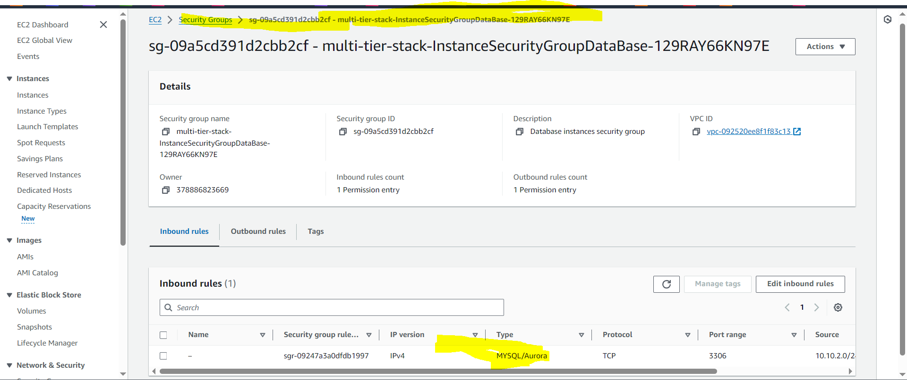

* Setup a Route 53 hosted zone and direct traffic to the EC2 instance.

* Development teams can test their code without having to involve the system admins and can invest their time in testing the code rather than provisioning, configuring, and updating the resources needed to test the code.
* The Development Team would have the necessary access in the deployed stack template launched by system admins to test the code and to delete the stack when it’s not needed.
* Make sure when the development team deletes the stack, RDS DB instances should not be deleted.
* Below is an example that, when we deleted the stack, RDS DB Instance did not deleted since we have enabled delete protection.

**Mission Complete**